Step-1:-Created a custom role.

First we have to create one JSON format file in which we have to state input we require.

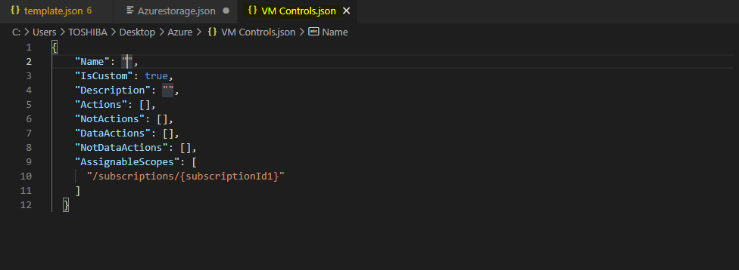

After providing all the details on JSON file save the file .

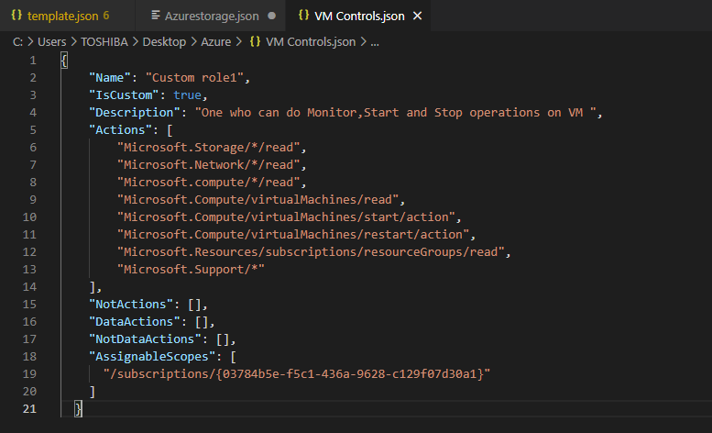

Then go abck to portal and run CLI command line give “az role definition update –role-definition ‘file name’ ”.

Before we have to upload the JSON file while we created to CLI command line.

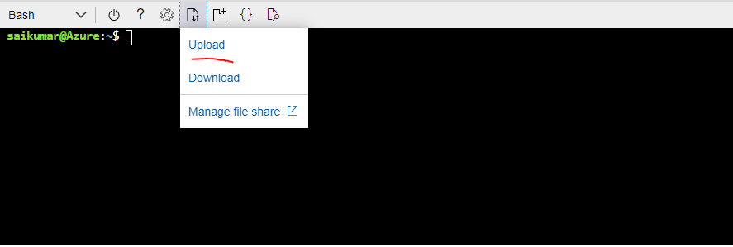

Step-2:-Created Recovery service Vault.

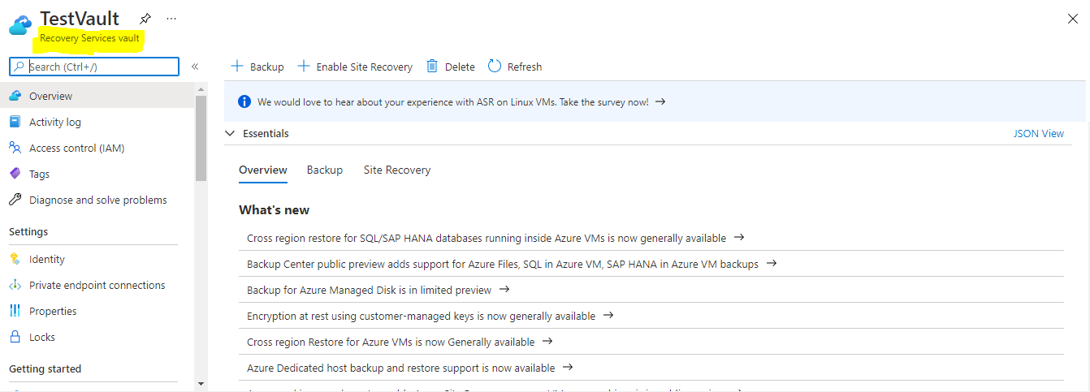

Step-3:-Took a Backup for VM that we deployed

